# Logging and Monitoring Azure API Management

## Metrics

Currently API Management offers below five metrics to track:

1. Failed Gateway Requests
2. Other Gateway Requests
3. Successful Gateway Requests
4. Total Gateway Requests
5. Unauthorized Gateway Requests

Steps to configure:

1. Login to Azure Portal and Navigate to **API Management Service** -> **Metrics**.
2. Select the metric(s) needed, in this case all five metrics are selected.

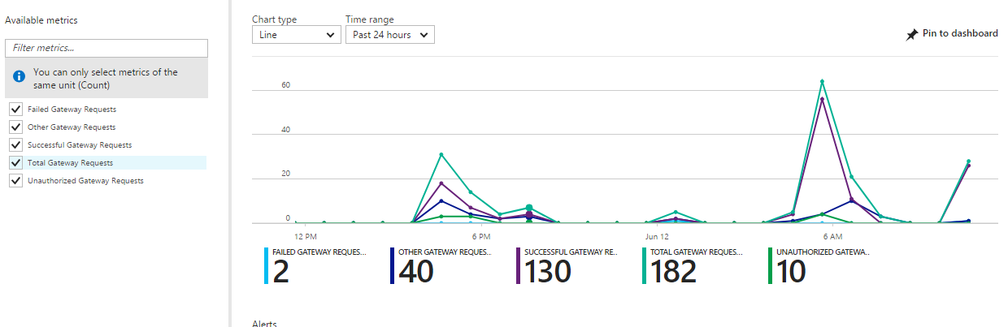

1. API Management metric also provides options to select resource type on which metrics needed as below.

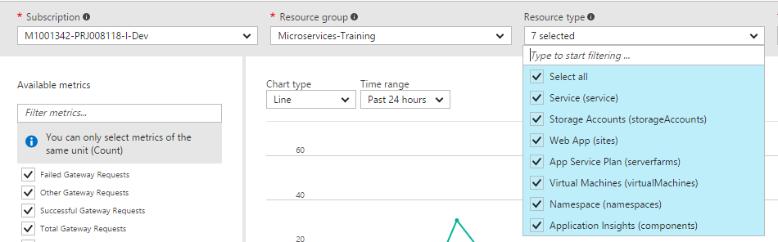

1. Based on respective requirement the OOTB chart give options for time range as:

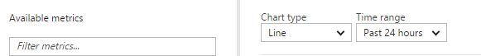

## Activity logs

1. Login to Azure Portal; navigate to **API Management Service** -> **Activity log**
2. Using activity logs, you can determine the "what, who, and when" for any write operations (PUT, POST, DELETE) taken on your API Management services.
3. Select columns and filter based on requirement.

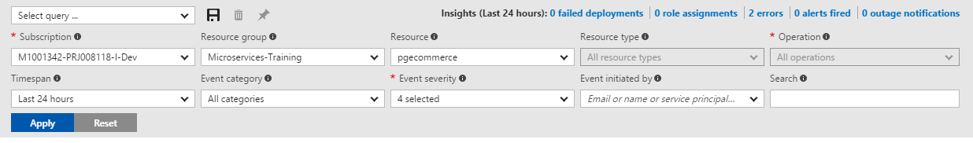

1. Output screen of the above filter will look like:

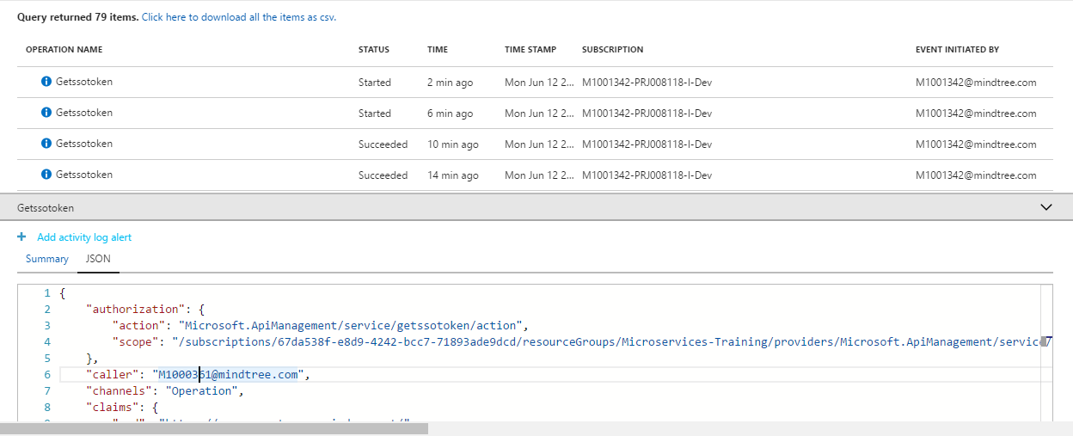

## Alerts

1. Login to Azure Portal; navigate to **API Management Service** -> **Alert Rules**.
2. Add Metric Alert:

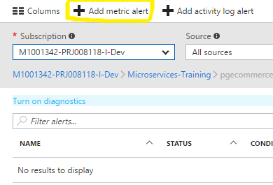

1. Add field’s details and click ‘OK’.

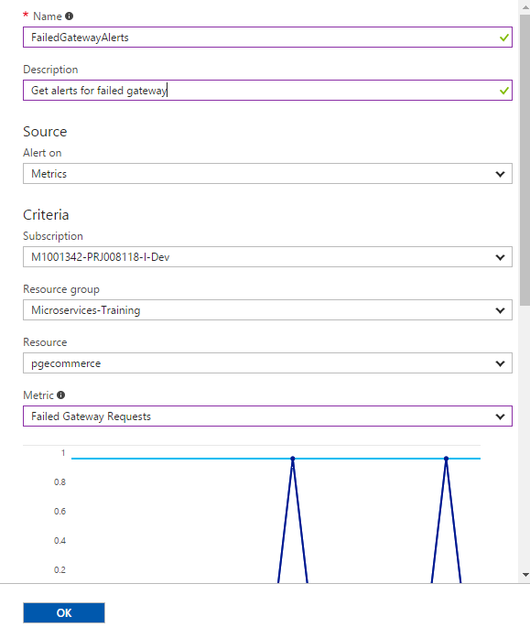

1. Click on ‘Condition’ to modify condition based on requirement.

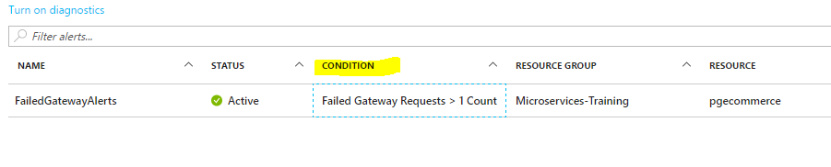

1. Modify the below fields and save the changes.

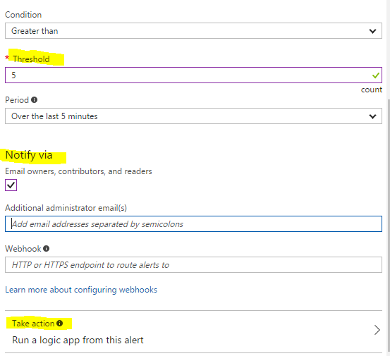

1. Enable ‘Take action’ if needed.

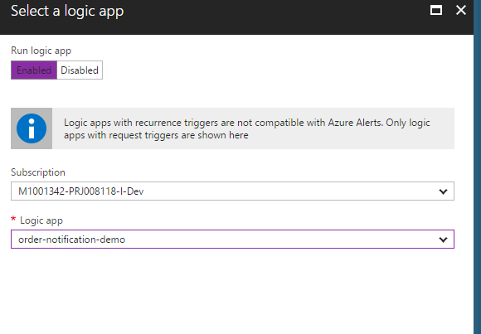

1. Add Activity Log alert:



1. Enter the highlighted fields and click ‘Save’. Also update the Actions area in the same screen.

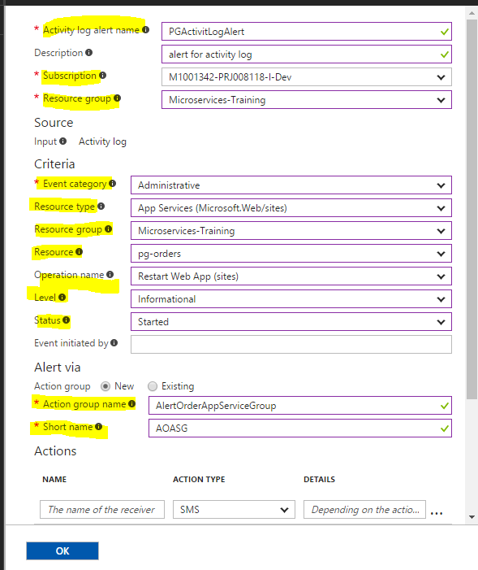

## Diagnostics

1. Login to Azure Portal; navigate to **API Management Service** -> **Diagnostics Log**
2. Turn on the Diagnostic for the API Management service.

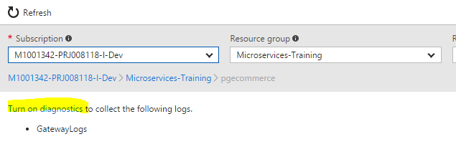

1. Configure diagnostic to log into storage account. Click ‘OK’ and then click ‘Save’.

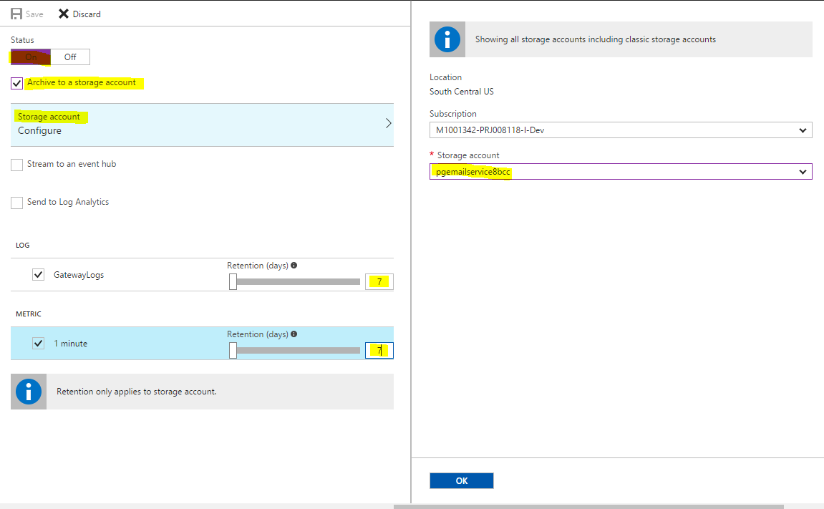

1. Check the log from landing screen of Diagnostic logs.

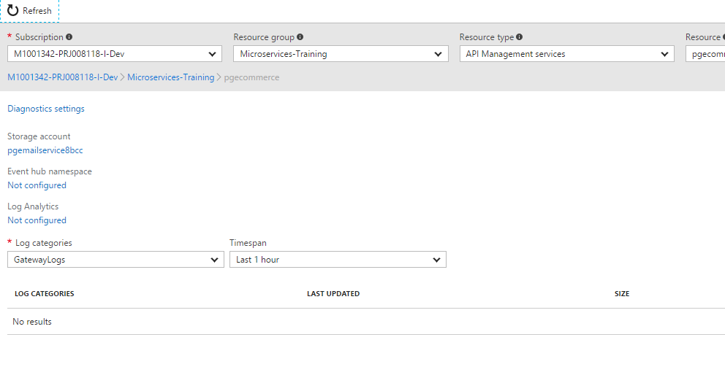

## using APplication Insights

1. Add Application Insights to Azure APP. Login to Azure Portal and navigate to Azure App(pg-products-assets).
2. Navigate to Application Insights screen.

Follow the below screens to set up Application Insights.



1. Login to Azure Portal; navigate to API Management Service -> Metrics.
2. If API under API management uses Application Insights, will get metrics in below screen.

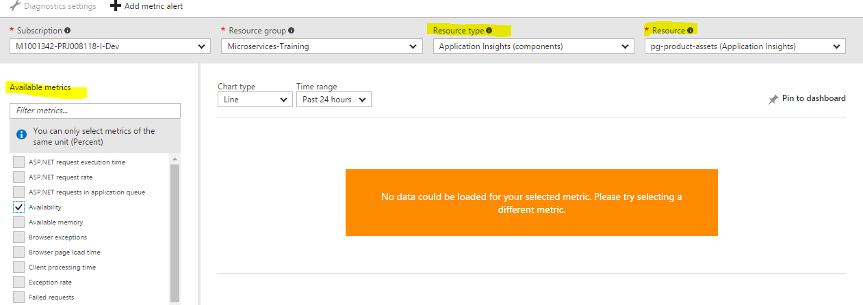

## Metrics and logs for respective APIs

1. Login to Azure Portal; Navigate to **API Management Service** -> **APIs – Preview**
2. Navigate to Publisher Portal.

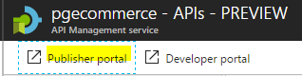

1. Navigate to Analytics:

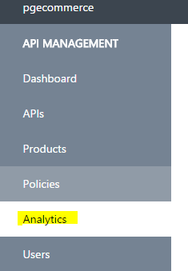

1. Below areas can be tracked for all APIs under this API Management service:

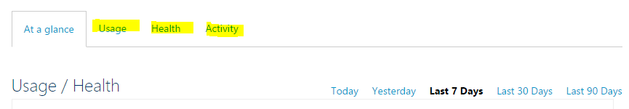

1. For respective API, use filter to fetch the details.

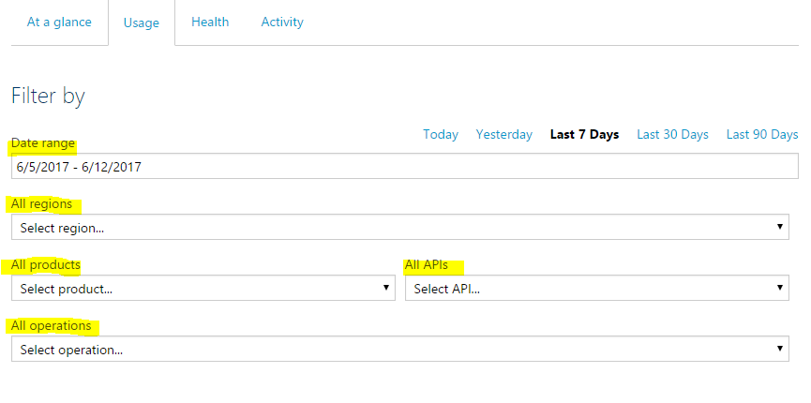

## References

* <https://docs.microsoft.com/en-us/azure/api-management/api-management-howto-use-azure-monitor>
* <https://docs.microsoft.com/en-us/azure/monitoring-and-diagnostics/monitoring-overview-of-diagnostic-logs>
* <https://docs.microsoft.com/en-us/azure/monitoring-and-diagnostics/monitoring-activity-log-alerts>
* <https://docs.microsoft.com/en-us/azure/application-insights/app-insights-azure-web-apps>